1.opendaylight Setting

My system is a Chinese system, the name is Deppin Linux , not necessarily my system, but if you want to change to my system

The following URL can be downloaded.

[https://www.deepin.org/download/](https://www.microsofttranslator.com/bv.aspx?from=zh-CHS&to=en&a=https%3A%2F%2Fwww.deepin.org%2Fdownload%2F)

the software that runs the virtual machine is called VMware Workstation Pro

[https://my.vmware.com/en/web/vmware/info/slug/desktop_end_user_computing/vmware_workstation_pro/14_0?wd=& eqid=a4bb02f00000ac92000000065a43407b](https://www.microsofttranslator.com/bv.aspx?from=zh-CHS&to=en&a=https%3A%2F%2Fmy.vmware.com%2Fen%2Fweb%2Fvmware%2Finfo%2Fslug%2Fdesktop_end_user_computing%2Fvmware_workstation_pro%2F14_0%3Fwd%3D%26eqid%3Da4bb02f00000ac92000000065a43407b)

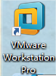

Tip 1. All my stuff is installed to / usr below.

Tip 2. because it is Ubuntu, so download package selection tar.gz format.

Tip 3. VI ~/.BASHRC This instruction was entered after the desktop opened the console, in other words, the root node of this instruction is Desktop . You can also change this command to gedit ~/.BASHRC, which opens the configuration file with a text editor.

**Here is the process**

JDK installation and configuration reference:

[Http://www.linuxidc.com/Linux/2016-05/131348.htm](https://www.microsofttranslator.com/bv.aspx?from=zh-CHS&to=en&a=http%3A%2F%2Fwww.linuxidc.com%2FLinux%2F2016-05%2F131348.htm)

PS : Download 1.8.0_152 .

Maven installation and configuration reference:

[Https://www.cnblogs.com/EasonJim/p/6831901.html](https://www.microsofttranslator.com/bv.aspx?from=zh-CHS&to=en&a=https%3A%2F%2Fwww.cnblogs.com%2FEasonJim%2Fp%2F6831901.html)

PS : Maven 3.3+ Required JDK 1.7 or later. The latest version is the Apache Maven 3.5.2. Nothing can say, just do what you write on the Web page.

OpenDayLinght installation Configuration reference:

[Http://docs.opendaylight.org/en/stable-nitrogen/getting-started-guide/installing_opendaylight.html](https://www.microsofttranslator.com/bv.aspx?from=zh-CHS&to=en&a=http%3A%2F%2Fdocs.opendaylight.org%2Fen%2Fstable-nitrogen%2Fgetting-started-guide%2Finstalling_opendaylight.html)

1. Download

[Https://www.opendaylight.org/technical-community/getting-started-for-developers/downloads-and-documentation](https://www.microsofttranslator.com/bv.aspx?from=zh-CHS&to=en&a=https%3A%2F%2Fwww.opendaylight.org%2Ftechnical-community%2Fgetting-started-for-developers%2Fdownloads-and-documentation)

The version selected here is Nitrogen SR1 .

2. Extract

unzip to where, I was extracted to / usr .

3. Execute instructions at root ./bin/karaf

[http://blog.csdn.net/little3344/article/details/46982403](https://www.microsofttranslator.com/bv.aspx?from=zh-CHS&to=en&a=http%3A%2F%2Fblog.csdn.net%2Flittle3344%2Farticle%2Fdetails%2F46982403)( One of the issues)

This picture will appear if successful

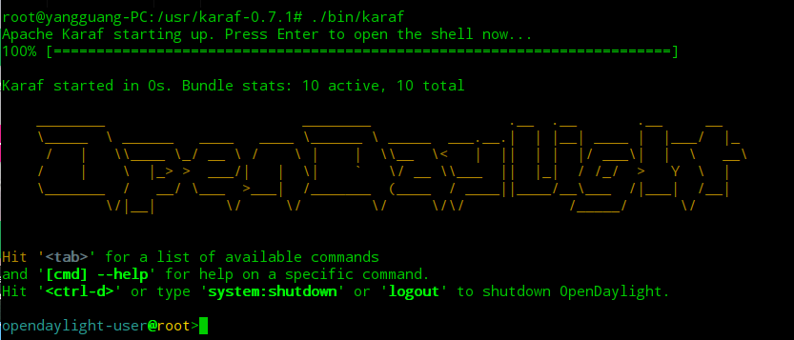

4. Install Components

[http://docs.opendaylight.org/en/stable-nitrogen/getting-started-guide/installing_opendaylight.html](https://www.microsofttranslator.com/bv.aspx?from=zh-CHS&to=en&a=http%3A%2F%2Fdocs.opendaylight.org%2Fen%2Fstable-nitrogen%2Fgetting-started-guide%2Finstalling_opendaylight.html) ( All components list, you can also use the instructions feature:list View)

If you do not know what components to install, you can refer to the following instructions

feature:install odl-base-all odl-aaa-authn odl-restconf odl-nsf-all odl-adsal-northbound Odl-ovsdb-northbound odl-dlux-core webconsole odl-mdsal-apidocs(from book)

feature:install odl-restconf odl-l2switch-switch odl-mdsal-apidocs odl-dlux-core ( from Web site [http://blog.csdn.net/little3344/article/details/46982403](https://www.microsofttranslator.com/bv.aspx?from=zh-CHS&to=en&a=http%3A%2F%2Fblog.csdn.net%2Flittle3344%2Farticle%2Fdetails%2F46982403))

[http://www.sdnlab.com/1931.html](https://www.microsofttranslator.com/bv.aspx?from=zh-CHS&to=en&a=http%3A%2F%2Fwww.sdnlab.com%2F1931.html)( another)

All of the above are for older versions of the article, so there are many components whose names do not exist. Delete all the names you can't find. Only the correct name is installed.

I've installed all the components I can install, as mentioned above, but I still can't show them UI , so I find myself a component whose name is odl-dluxapps-applications . After you install this component, you can display the Web page UI normally .

5. Dlux

Google browser opens http://localhost:8181/index.html

continue to enter the username password if the login interface is displayed properly Admin .

6. UI Action

Reference official Internet Cafes

[http://docs.opendaylight.org/en/stable-nitrogen/user-guide/using-the-opendaylight-user-interface-(Dlux). html](https://www.microsofttranslator.com/bv.aspx?from=zh-CHS&to=en&a=http%3A%2F%2Fdocs.opendaylight.org%2Fen%2Fstable-nitrogen%2Fuser-guide%2Fusing-the-opendaylight-user-interface-(dlux).html)

other ( record only)

[http://blog.csdn.net/liubag/article/details/22947257](https://www.microsofttranslator.com/bv.aspx?from=zh-CHS&to=en&a=http%3A%2F%2Fblog.csdn.net%2Fliubag%2Farticle%2Fdetails%2F22947257)

2. mininetVM Virtual Machine

due to online downloads mininet. The virtual machine does not have a graphical interface, so the work is not going on. Although it has a lot of software installed, it can only be manipulated with instructions. So this word solves this problem.

in Windows Host Download Xshell and Xmanager

Both software can be downloaded directly from Baidu.

And both software can choose the Chinese interface. Reader network is also like Chinese software.

two Tip

Linux View IP the instruction is ifconfig

mininet VM the user name and password for the virtual machine are both mininet

Xshell How to use Reader network

[Http://www.xshellcn.com/xsh_column/yuancheng-lianjie.html](https://www.microsofttranslator.com/bv.aspx?from=zh-CHS&to=en&a=http%3A%2F%2Fwww.xshellcn.com%2Fxsh_column%2Fyuancheng-lianjie.html)

PS : In addition to the official online settings, you need to set up a place, in the connection configuration interface, find the left tree in the SSH , after you click Tunnel, there is a on the right page X11 Transfer, check box forwarding X11 Connect to ( X ) and the following Xmanager , so that automatic Wireshark There is no error.

In fact this extra setup is automatically done some work as to what work you can look at this URL

[Http://www.xshellcn.com/zhishi/xmdl-ff.html](https://www.microsofttranslator.com/bv.aspx?from=zh-CHS&to=en&a=http%3A%2F%2Fwww.xshellcn.com%2Fzhishi%2Fxmdl-ff.html)

If you do not set the above, the operation of this web site requires you to do it yourself.

then select Use Xshell log on to mininet host, using Xshell after you log on to the virtual machine, enter by keyboard xterm directives, Xshell To start automatically Xmanager and xterm the opens a window on the host to display.

in fact, at first it can be like open Ubuntu Open mininet virtual machine, and then enter ./xterm , but then it prompts the following

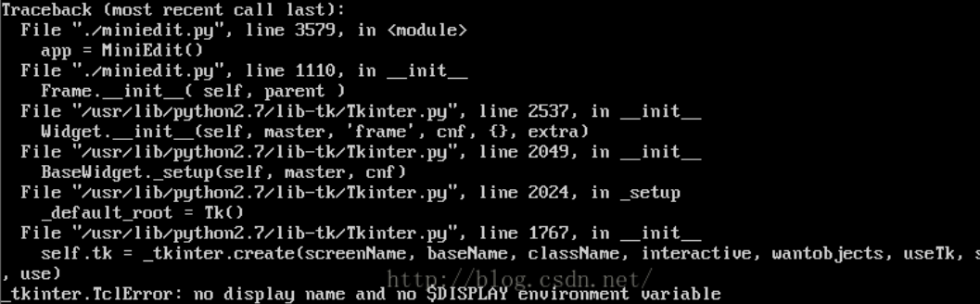

In fact, can not display the graphical interface.

Then enter Wireshark & automatically opens another Wireshark window. This software is used to grab the bag. So far, if the ODL and mininet have been configured, the environment will be built. Then do a solid learning network and openflow Bar. But we don't have much time.

other ( record only)

[http://blog.csdn.net/rock4you/article/details/52735444](https://www.microsofttranslator.com/bv.aspx?from=zh-CHS&to=en&a=http%3A%2F%2Fblog.csdn.net%2Frock4you%2Farticle%2Fdetails%2F52735444)

[http://blog.csdn.net/zhoulinshijie/article/details/78198639](https://www.microsofttranslator.com/bv.aspx?from=zh-CHS&to=en&a=http%3A%2F%2Fblog.csdn.net%2Fzhoulinshijie%2Farticle%2Fdetails%2F78198639)

[Http://www.xshellcn.com/zhishi/xmdl-ff.html](https://www.microsofttranslator.com/bv.aspx?from=zh-CHS&to=en&a=http%3A%2F%2Fwww.xshellcn.com%2Fzhishi%2Fxmdl-ff.html)

[http://blog.csdn.net/wuyao721/article/details/3678859](https://www.microsofttranslator.com/bv.aspx?from=zh-CHS&to=en&a=http%3A%2F%2Fblog.csdn.net%2Fwuyao721%2Farticle%2Fdetails%2F3678859)

[https://www.cnblogs.com/thelongroad/p/3264024.html](https://www.microsofttranslator.com/bv.aspx?from=zh-CHS&to=en&a=https%3A%2F%2Fwww.cnblogs.com%2Fthelongroad%2Fp%2F3264024.html) (What is mininet )

[http://blog.csdn.net/linyixiao88/article/details/65651390](https://www.microsofttranslator.com/bv.aspx?from=zh-CHS&to=en&a=http%3A%2F%2Fblog.csdn.net%2Flinyixiao88%2Farticle%2Fdetails%2F65651390%EF%BC%88mininet%E5%AE%89%E8%A3%85%E6%96%B9%E5%BC%8F%EF%BC%89) ( mininet How to install 1 )

[http://blog.csdn.net/simongeek/article/details/22777033](https://www.microsofttranslator.com/bv.aspx?from=zh-CHS&to=en&a=http%3A%2F%2Fblog.csdn.net%2Fsimongeek%2Farticle%2Fdetails%2F22777033) ( mininet How to install 2 )

[http://blog.csdn.net/u014015972/article/details/51133292](https://www.microsofttranslator.com/bv.aspx?from=zh-CHS&to=en&a=http%3A%2F%2Fblog.csdn.net%2Fu014015972%2Farticle%2Fdetails%2F51133292) ( mininet How to install 3 )

[Https://wenku.baidu.com/view/f7ace2b5b9f67c1cfad6195f312b3169a451eaf4.html](https://www.microsofttranslator.com/bv.aspx?from=zh-CHS&to=en&a=https%3A%2F%2Fwenku.baidu.com%2Fview%2Ff7ace2b5b9f67c1cfad6195f312b3169a451eaf4.html)

( mininet and ODL fit)